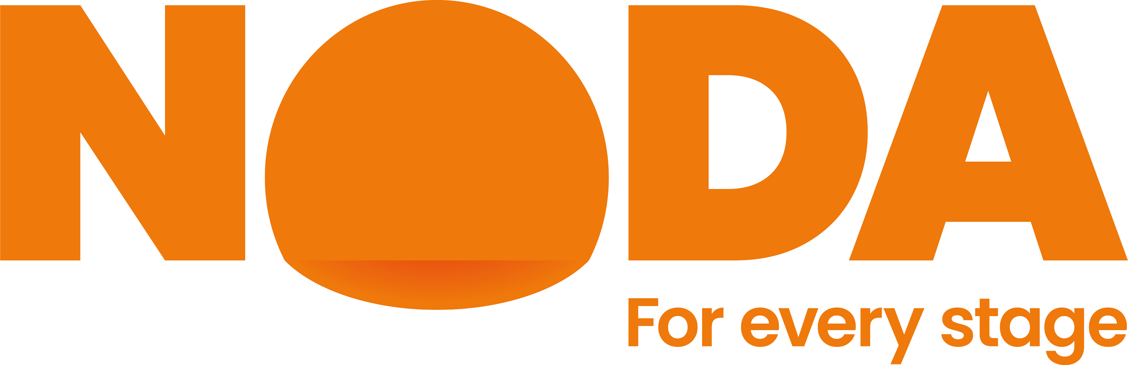

**NATIONAL OPERATIC & DRAMATIC ASSOCIATION**

**LONDON REGION**

**ELECTION OF REGIONAL REPRESENTATIVES FOR 2025-26**

**FORM A (*block capitals please)* Date / /**

I / We wish to nominate**………………………………a member of the……………………………… Society / Individual Member to represent District No. ….. for the year 2025-26.

Signed: ……………………………… (Secretary) Society ………………………………………

………………………………...(Chairman) *Please note both signatures are required*

Individual Member …………………………………….. Joint Members ……………………………...

**FORM B (*block capitals please)* Date / /**

I hereby attest to my consent to serve on the London Regional Committee to represent District No. …. and confirm my eligibility in accordance with Rule 19 (8)(a)* of the Association.

Signed: ……………………………………….. Full name: ……………………………….

Address: ...……………………………………………………………………………………...

Post Code: ……….. Telephone: ………………… Email: ………………………………..

*Rule 19 (8)(a) states “Only people who are nominated by people and/or organisations that hold at least 15 votes and who are members of a Society allocated to that District are eligible for election as Regional Representative.

**For clarity, An existing rep standing for re-election is deemed to have been nominated under rule 19 (8) (a) as per Rule 19 (8) (c) If a nomination is made for someone other than the existing or nominated Regional Representative, it must be supported by the equivalent of fifteen votes. Each nominating Society has five votes, each Individual Member one vote and Joint Members two votes

A Nominee need only sign one consent –Form B.

**Please return Forms A and B to the Regional Councillor, Pam Armstrong, 42 Inglis Road, Ealing, London W5 3RL only if you wish to nominate someone other than the present Regional Representative for your District. The last date for receipt of nominations shall be 26th May 2025. In the event of more than one nomination the election shall be decided by a postal ballot in accordance with Rule 11 (8) of the Association.**