DE-LUXE CLASS PROGRAMME COMPETITION
Winner - Shakespeare at the George
Owen Peacock Trophy - East Region
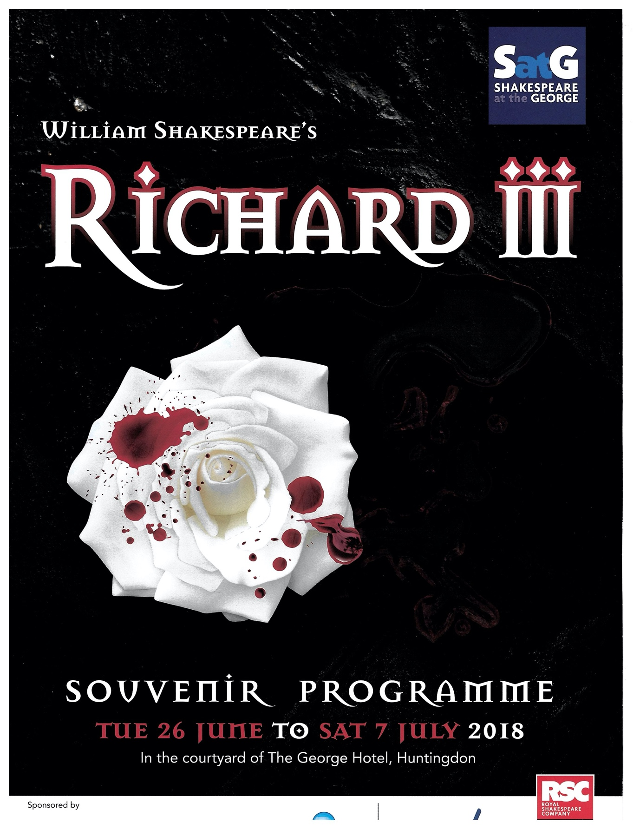

Runner up - BMOS Musical Theatre Company
The Ralph Whittaker Trophy - West Midlands Region
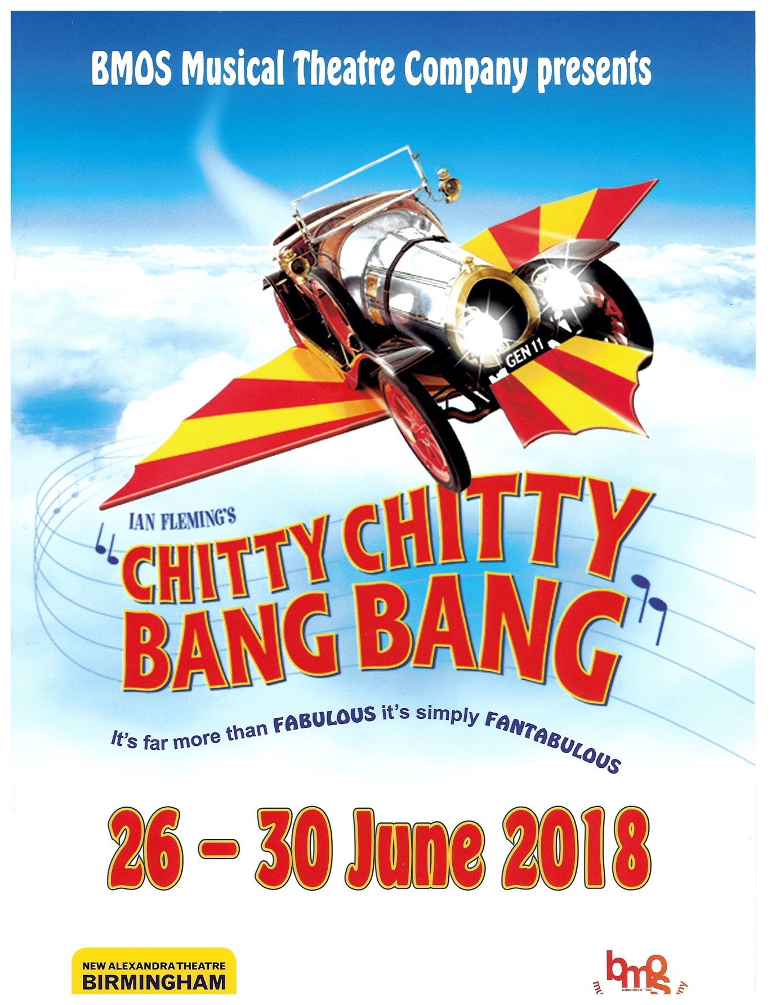

STANDARD CLASS PROGRAMME
Winner - Alnwick Stage Musical Society - My Fair Lady
The RTH Perkins Trophy - North Region
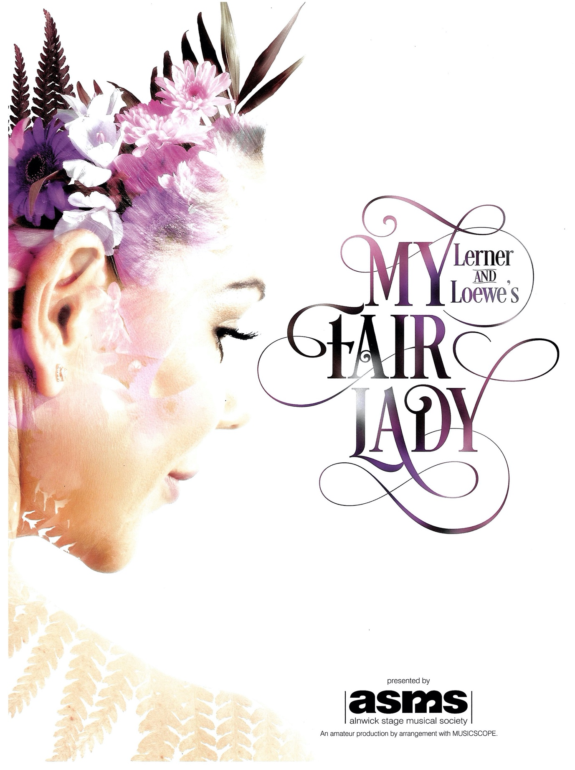

Runner up - Dinnington Operatic Society - The Beauty & the Beast
The Kay Darbyshire Trophy - North East Region
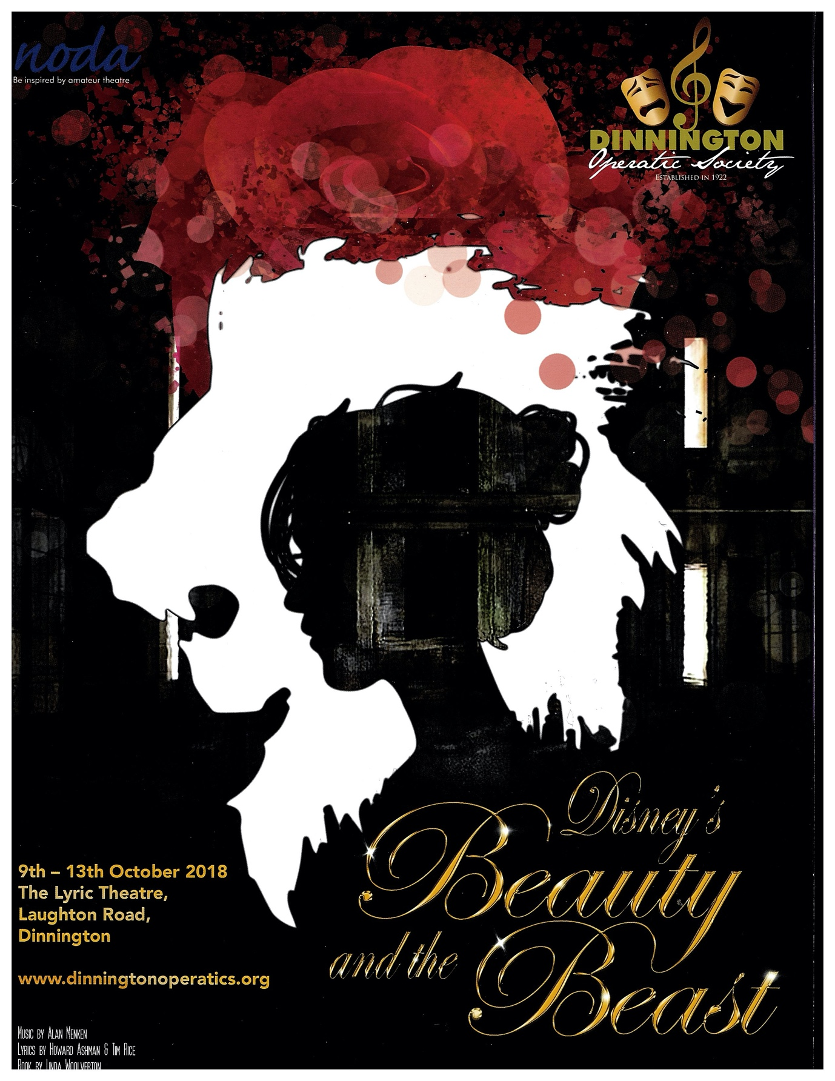

BasIC Class Programme
Winner - Present Stage Theatre Company - Blithe Spirit
The Barnes Trophy - Wales & Ireland Region
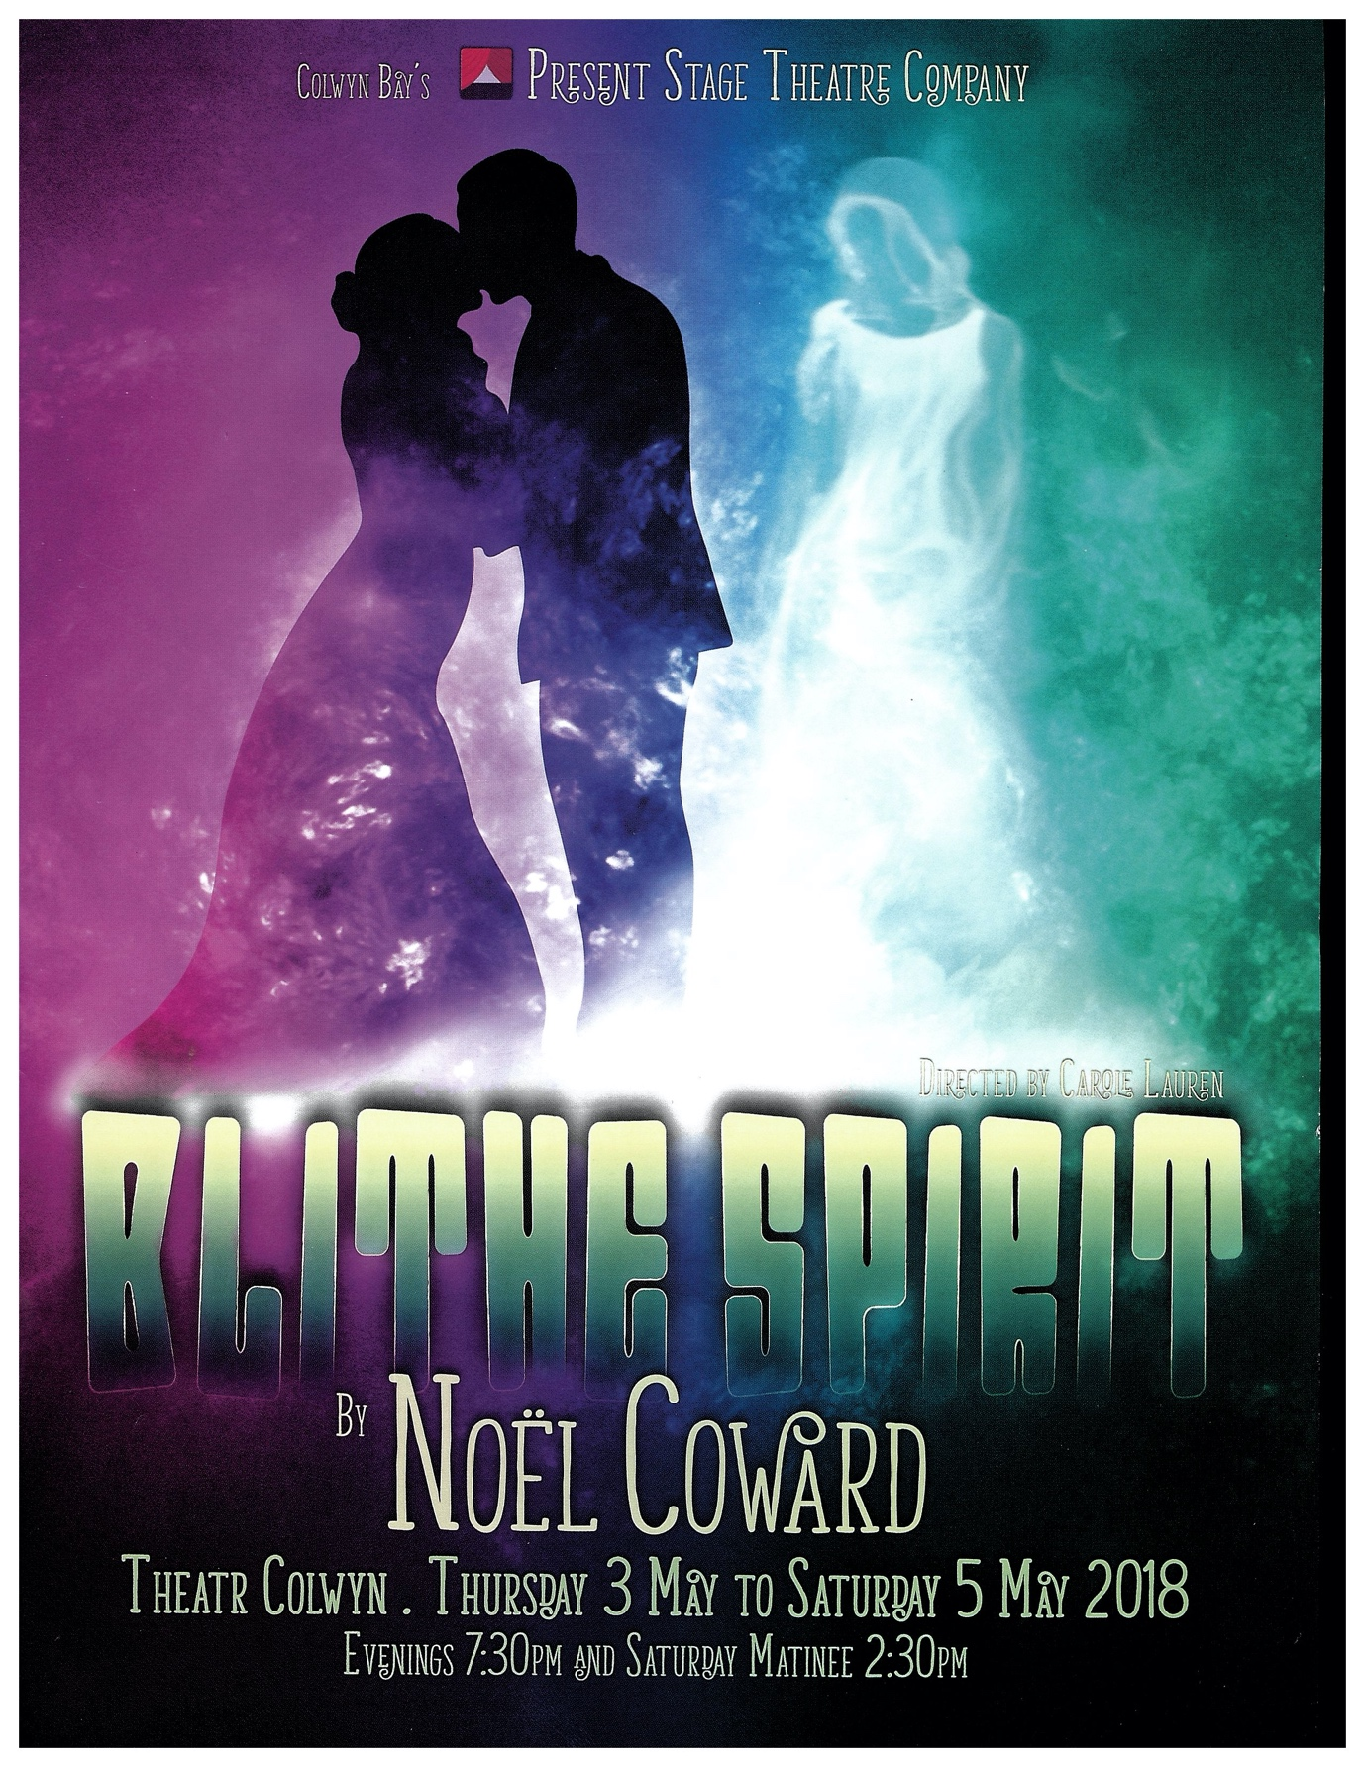

Runner Up - Manchester Musical Youth - Guys & Dolls
The Underwood Quaich - North West Region
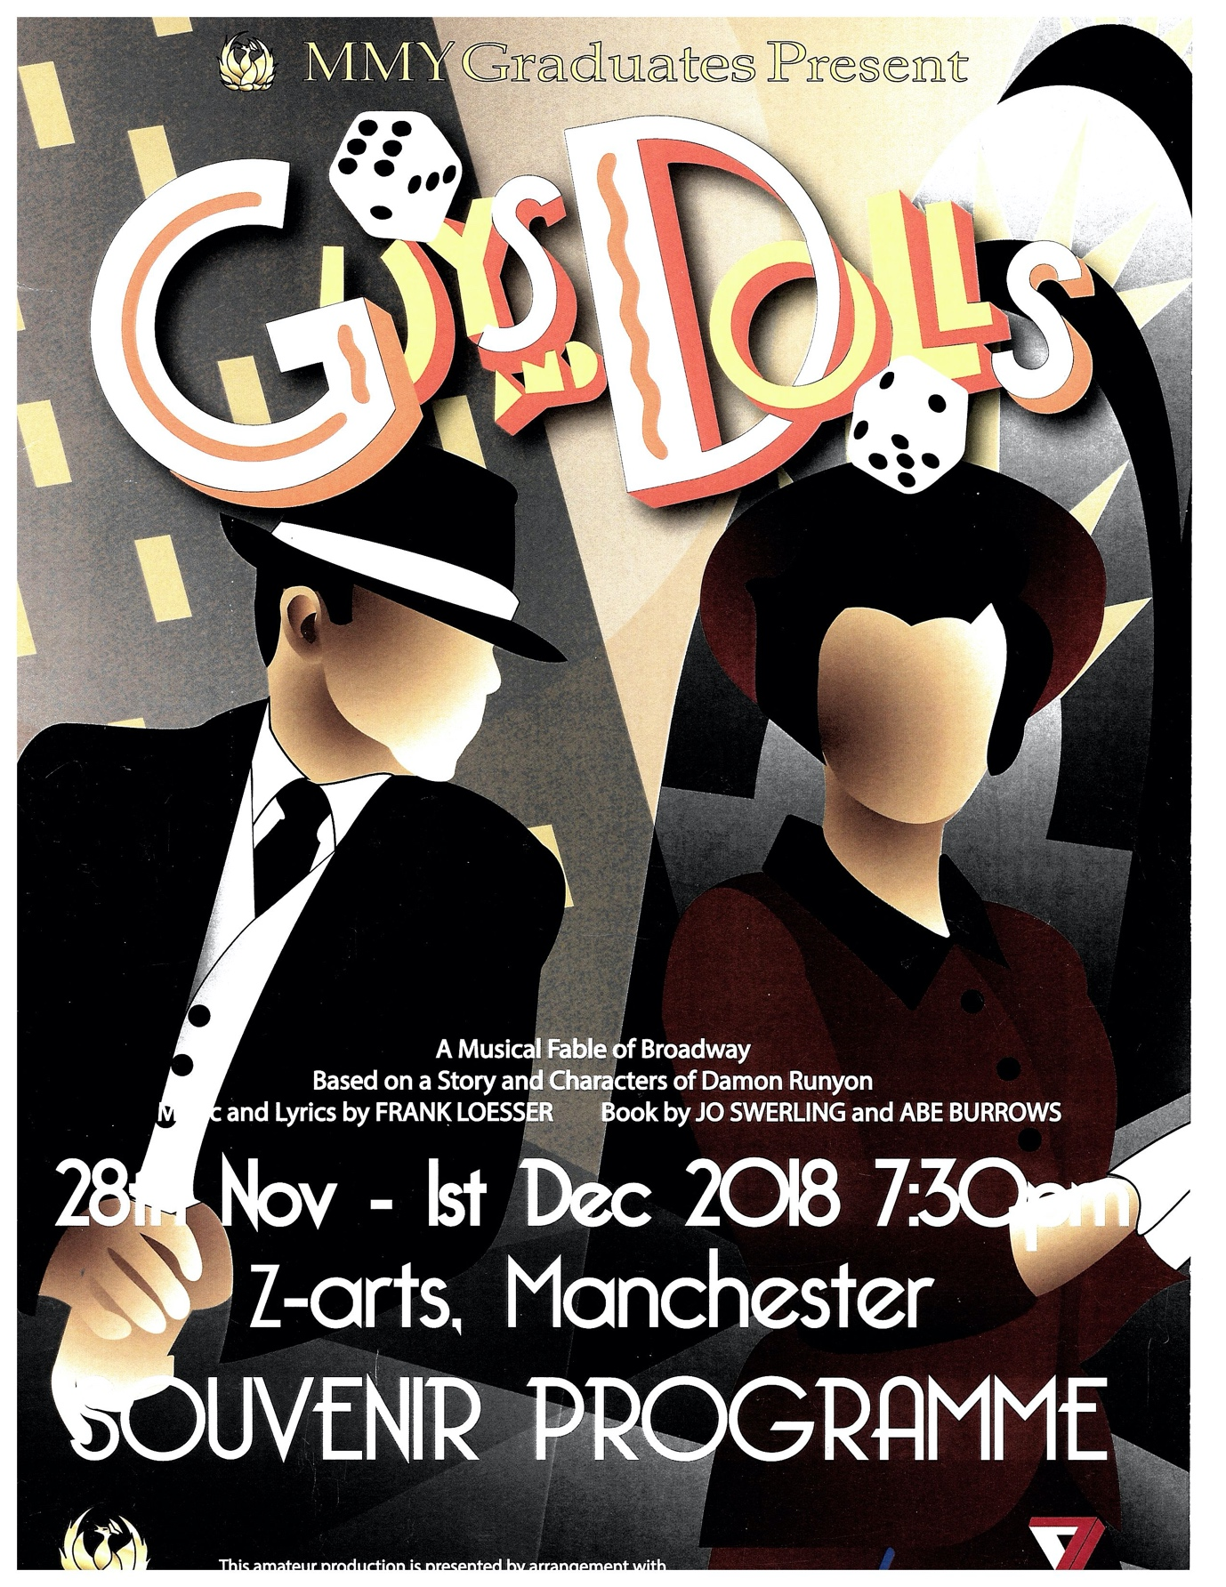

POSTER COMPETITION
Winner - Belmont Theatre Company - Journey's End
The Thomson-Leng Trophy - London region
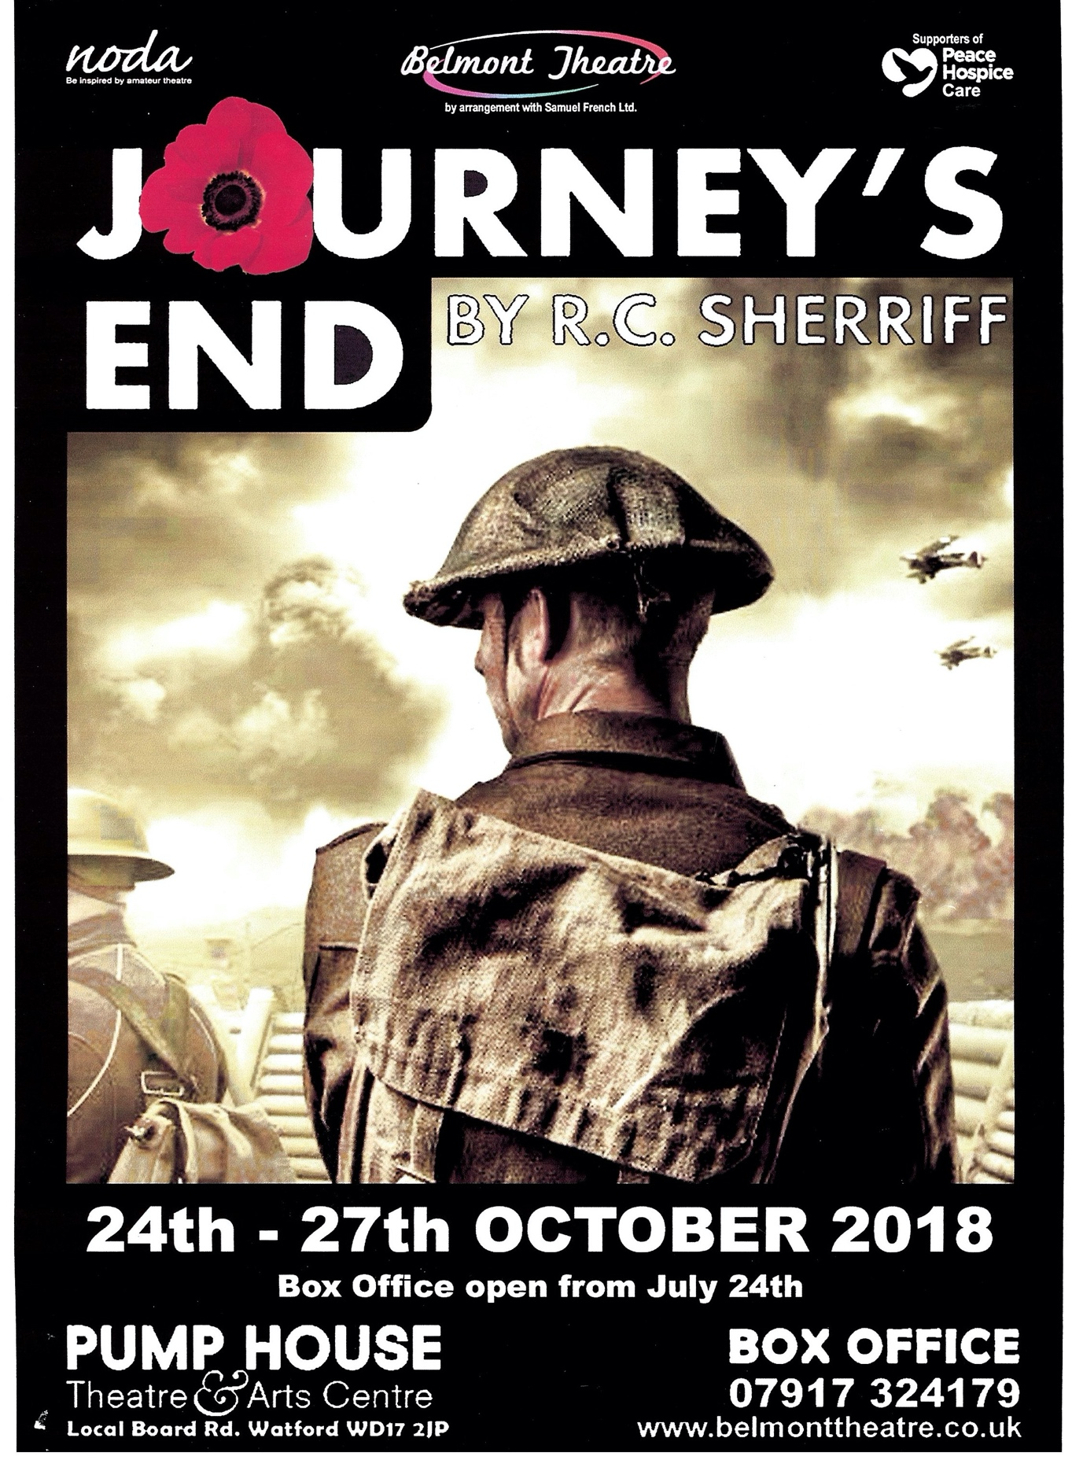

Runner Up - Bradfordians Dramatic Society -Harvey
The Bill & Nora Timmens Trophy - South West Region

